**Optimizing User, Group, and Role Management with Access Control and Workflows**

Team ID : NM2025TMID15452

Team Size : 4

Team Leader : NAVEEN KUMAR S

Team member : DHINESH KUMAR O

Team member : SOUNDAR RAJAN R

Team member : SANJAY R

Problem Statement:

In a small project management team consisting of a Project Manager (Alice) and a Team Member (Bob), there is a need to efficiently manage project tasks and ensure accountability through out the project lifecycle.The current system lacks clear role definitions, access controls, and a structured workflow, leading to confusion regarding task assignments and progress tracking.

Objective:

1. **Define User Roles Clearly:** Establish distinct roles for Alice (Project Manager) and Bob (Team Member) to ensure clarity in responsibilities and access rights within the project management tool.
2. **Implement Access Control Mechanisms:** Create a system that restricts Bob’s access to project creation and editing features while allowing him to view and update his assigned tasks, thereby preventing unauthorized changes.
3. **Streamline Workflow Processes:** Develop a structured work flow for task assignment and progress tracking, ensuring that Alice can easily assign tasks to Bob and monitor their completion in a timely manner.

**Skills:**Users,Groups,Roles,Tables,AccessControlList,FlowDesigner

TASK INITIATION:

**Milestone 1 : Users Activity1:CreateUsers**

* 1. Open servicenow
  2. Click on All>>search for users
  3. Select Users under system security
  4. Click on new
  5. Fill the following details to create a new user
  6. 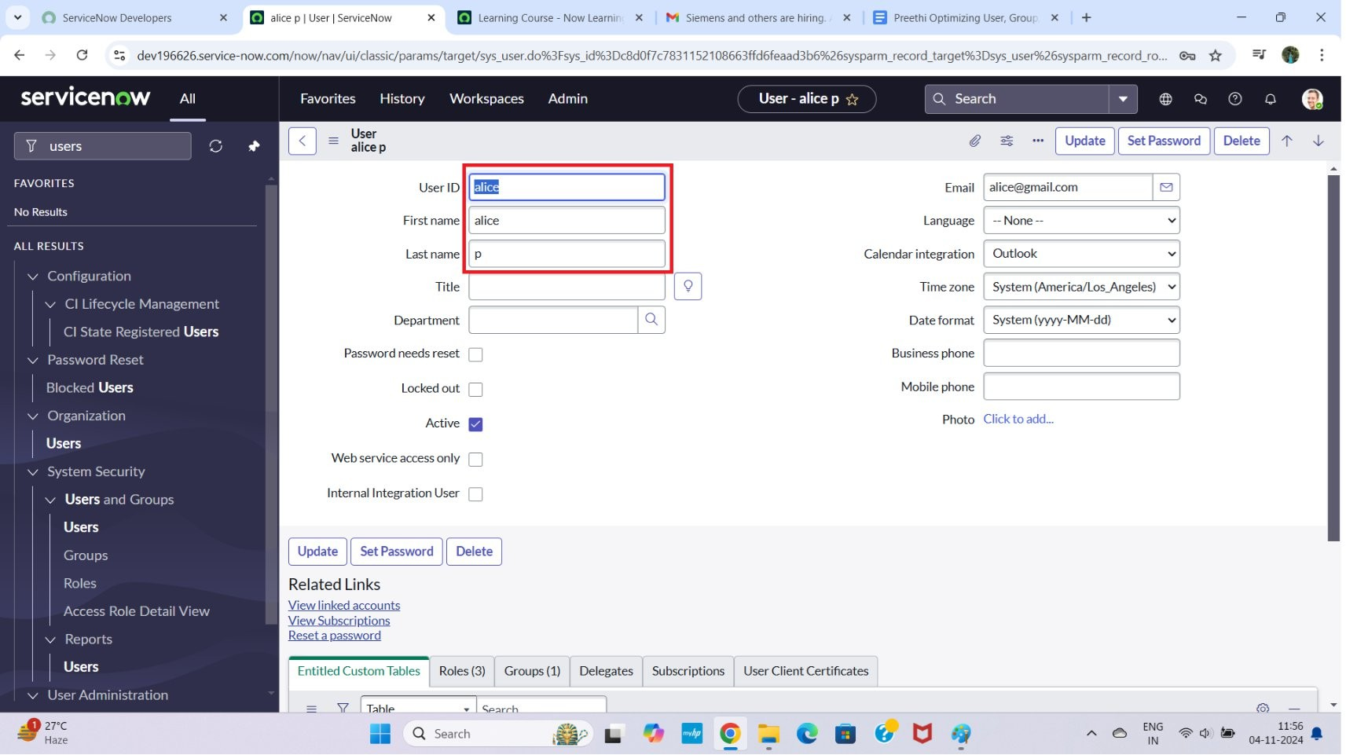Click on submit.

**Create one more user:**

7. Create another user with the following details

8. Click on submit button.

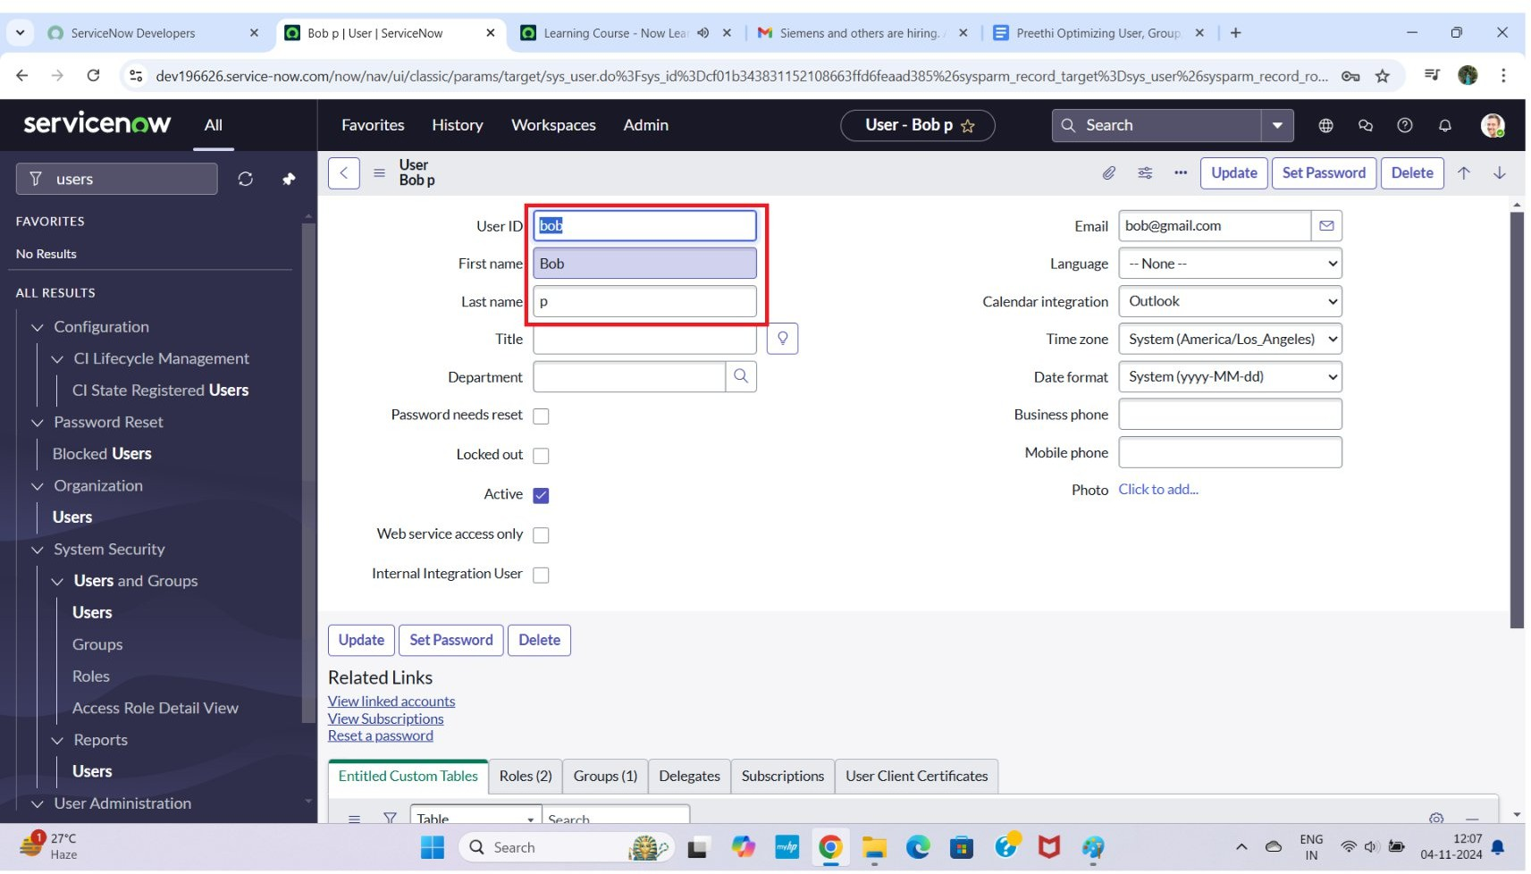

Milestone 2 : Groups Activity1:CreateGroup

1. Open service now.
2. Click on All>>search for groups
3. Select groups under system security
4. Click on new button
5. Then Fill the following details to create a new group
6. Click on submit Button

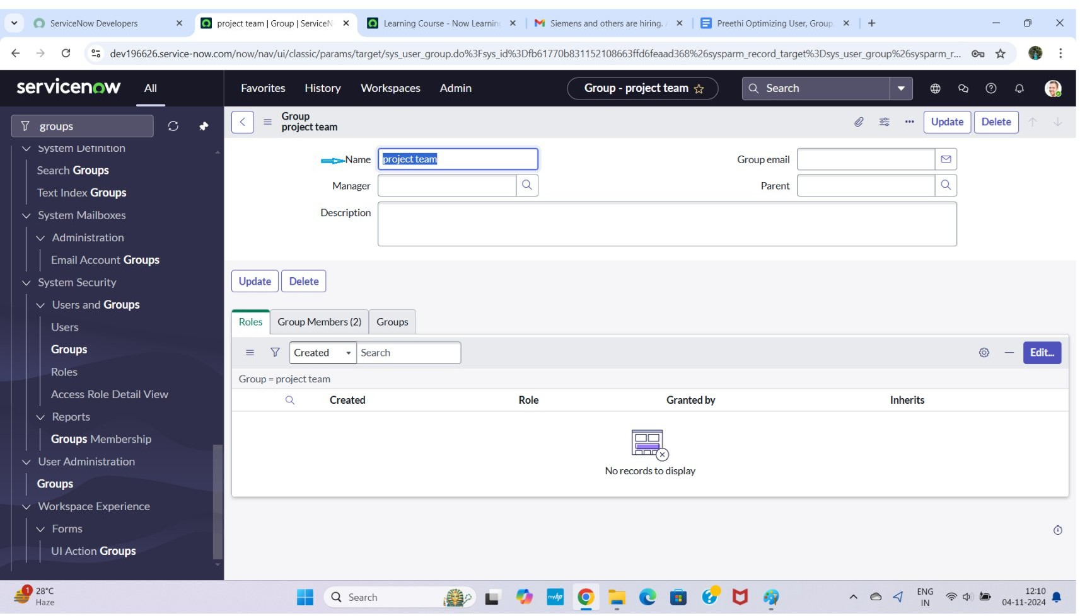

Milestone 3 : Roles

Activity 1:Create roles

1. Open servicenow.
2. Click on All>>search for roles
3. Select roles under system security
4. Click on new button
5. Fill the following details to create a new role
6. Click on submit.

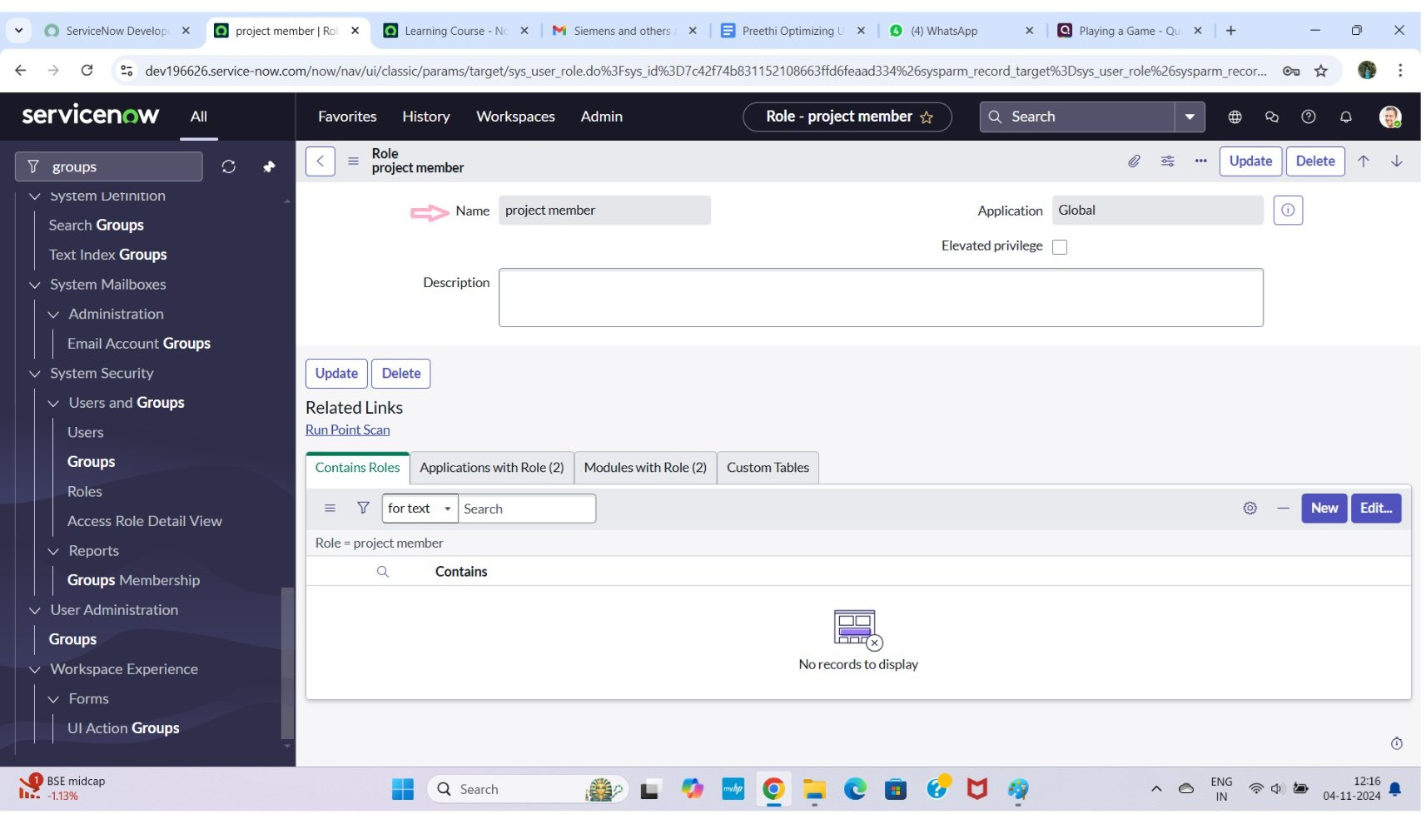

Createonemorerole:

1. Create an other role with the following details
2. Click on submit

Milestone 4 : Table Activity1:CreateTable

1. Open servicenow.
2. Click on All>>search for tables
3. Select tables under system definition
4. Click on new
5. Fill the following details to create a new table Label : project table
6. Check the boxes Create module & Create mobile module
7. Under new menu name: project table
8. Under table columns give the columns

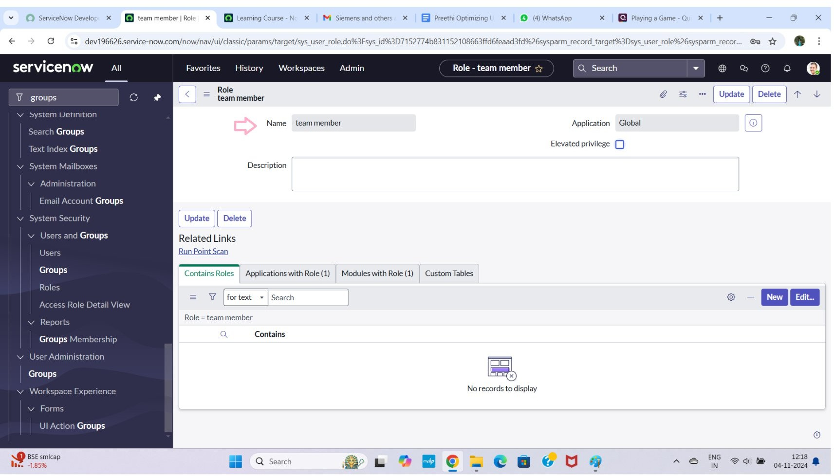

1. Clickonsubmit

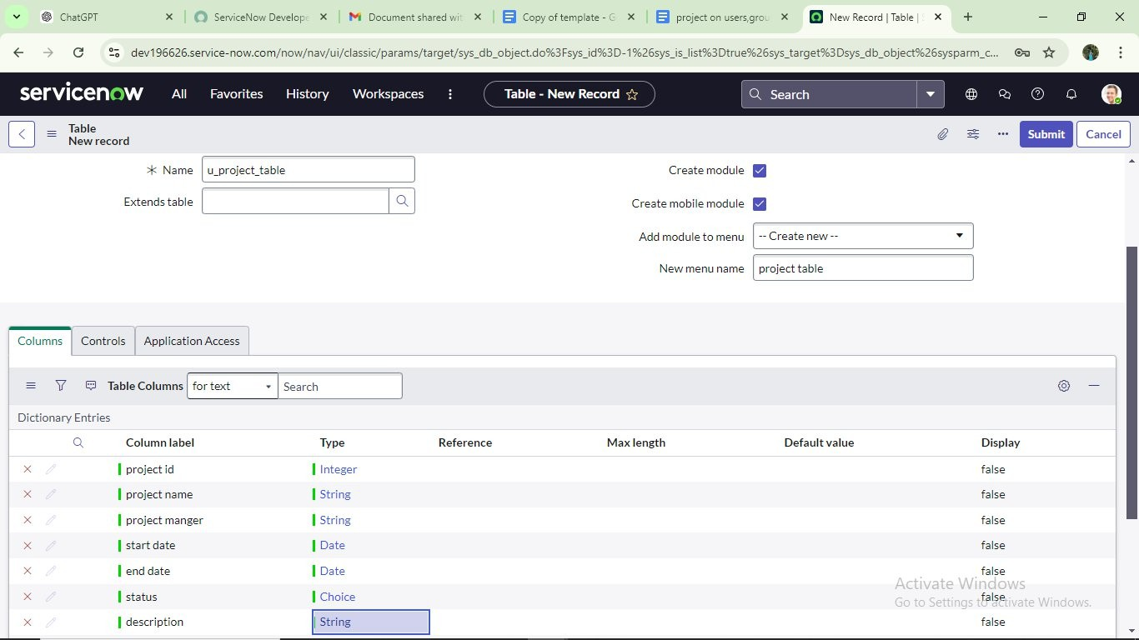

Createonemoretable:

1. Create another table as: task table 2 and fill with following details.
2. Click on submit.

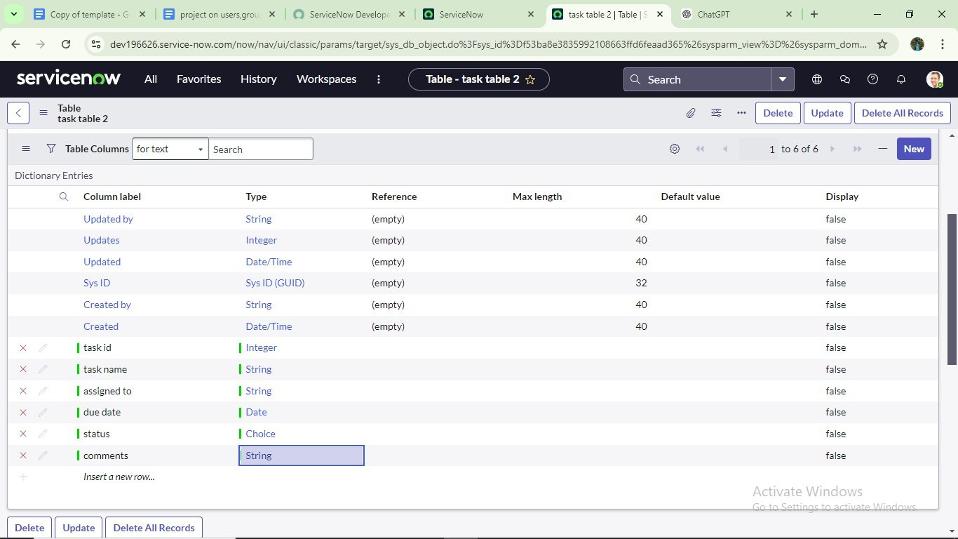

Milestone5:Assignuserstogroups

**Activity1:Assignuserstoprojectteamgroup**

* 1. Open servicenow.
  2. Click on All>>search for groups
  3. Select tables under system definition
  4. Select the project team group
  5. Under group members
  6. Click on edit
  7. Select alice p and bob p and save

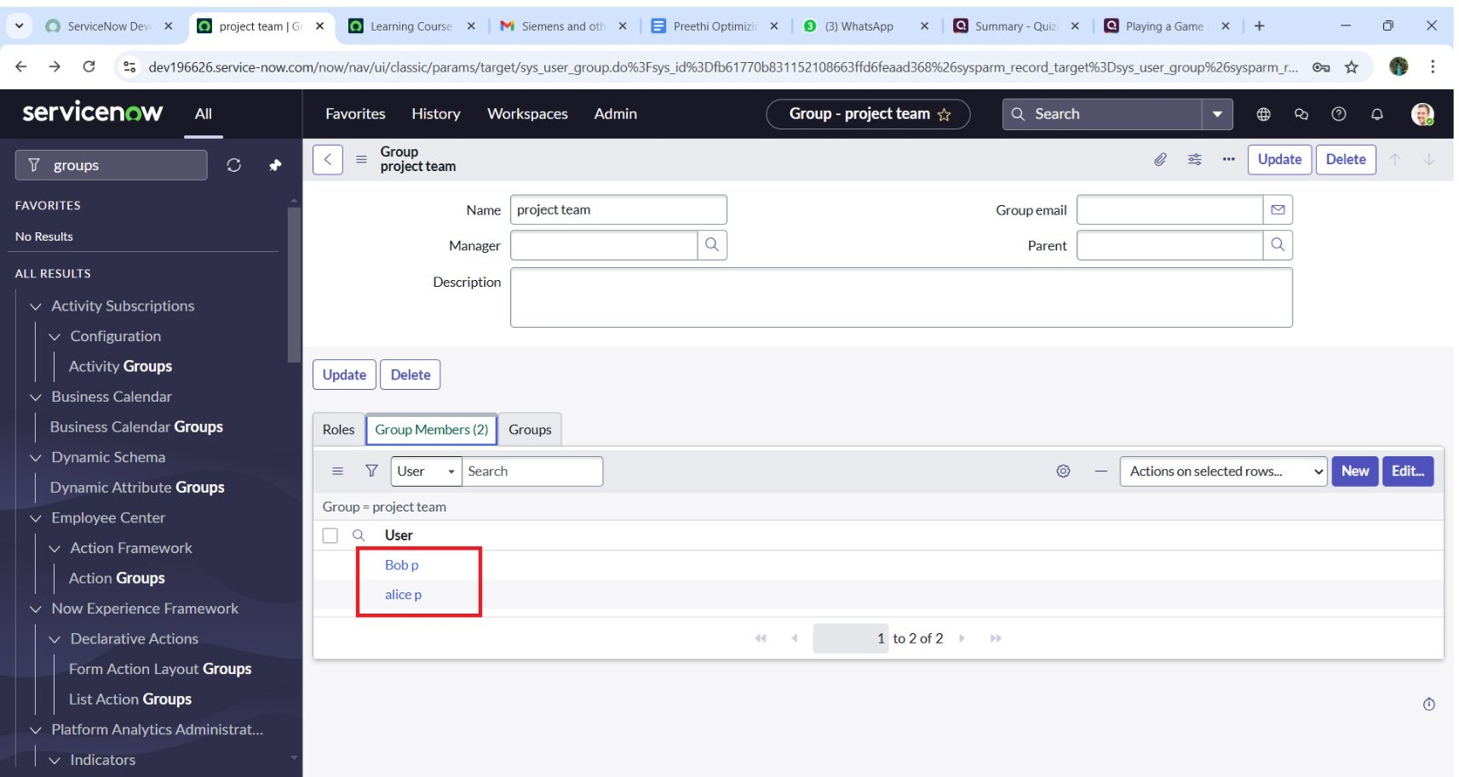

Milestone 6 : Assign roles to users Activity1:Assign roles to alice user

1. Open servicenow. Click on All>>search for user
2. Select tables under system definition
3. Select the project manager user
4. Under project manager
5. Click on edit
6. Select project member and save
7. Click on edit add u_project_table role and u_task_table role
8. Click on save and update the form.

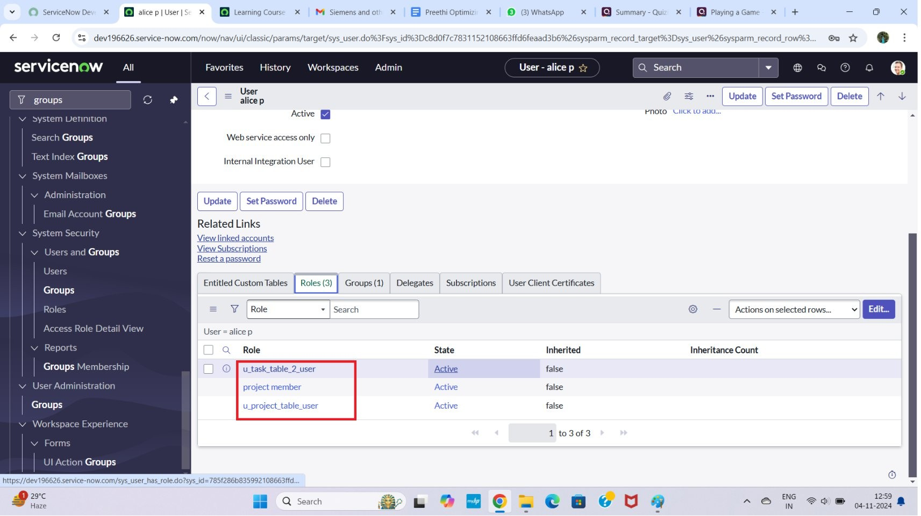

Activity2:Assign roles to bob user

1. Open servicenow. Click on All>>search for user
2. Select tables under system definition
3. Select the bob p user
4. Under team member
5. Click on edit
6. Select team member and give table role and save
7. Click on profile icon Impersonate user to bob
8. We can see the task table2.

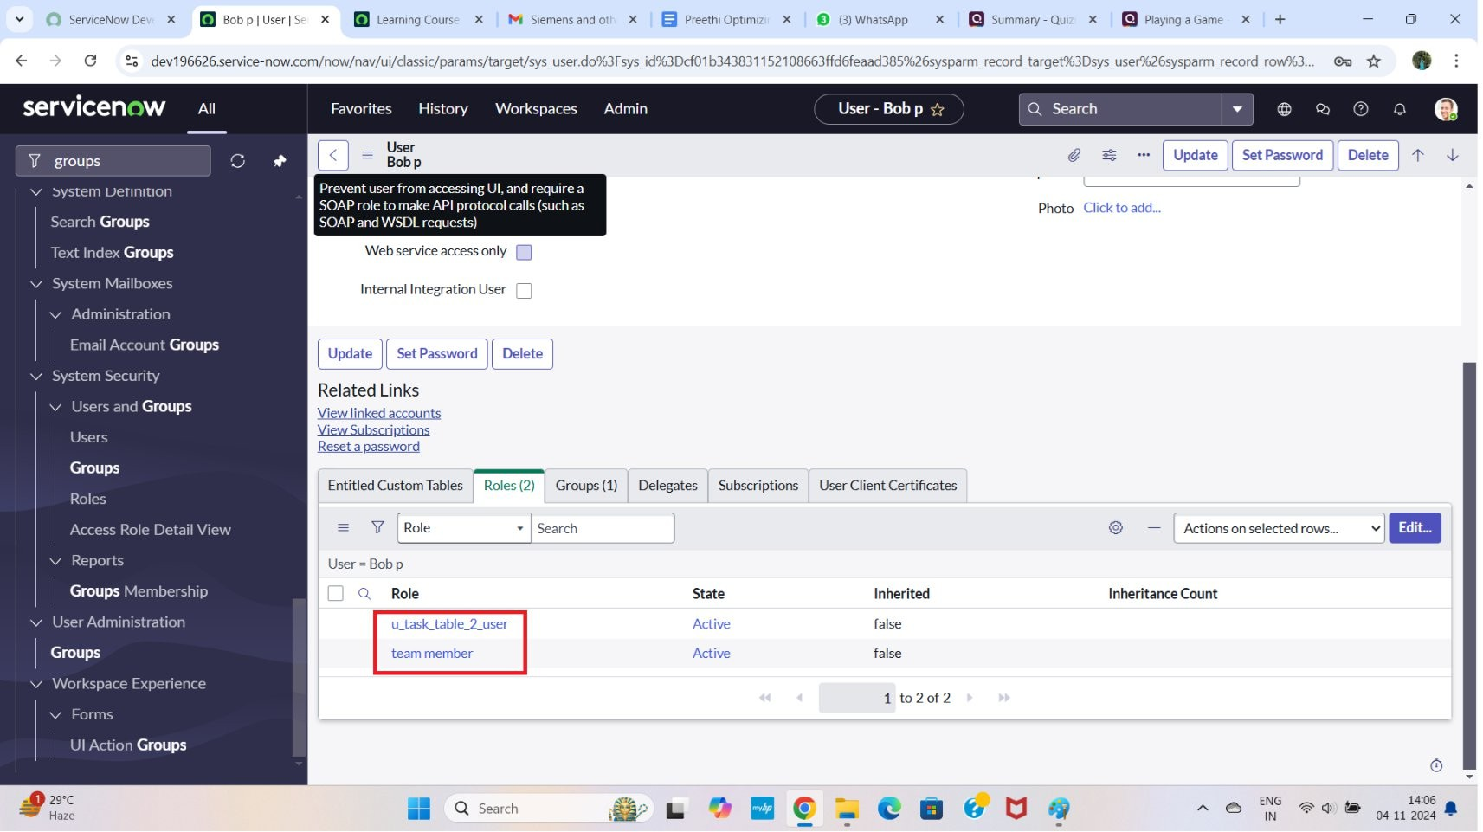

Milestone7:Applicationaccess

**Activity1:Assigntable access to application**

1. While creating a table it automatically create a application and module for that table
2. Go to application navigator search for search project table application
3. Click oned it module
4. Give project member roles to that application
5. Search for task table 2 and click oned it application.
6. Give the project member and team member role for task table 2 application

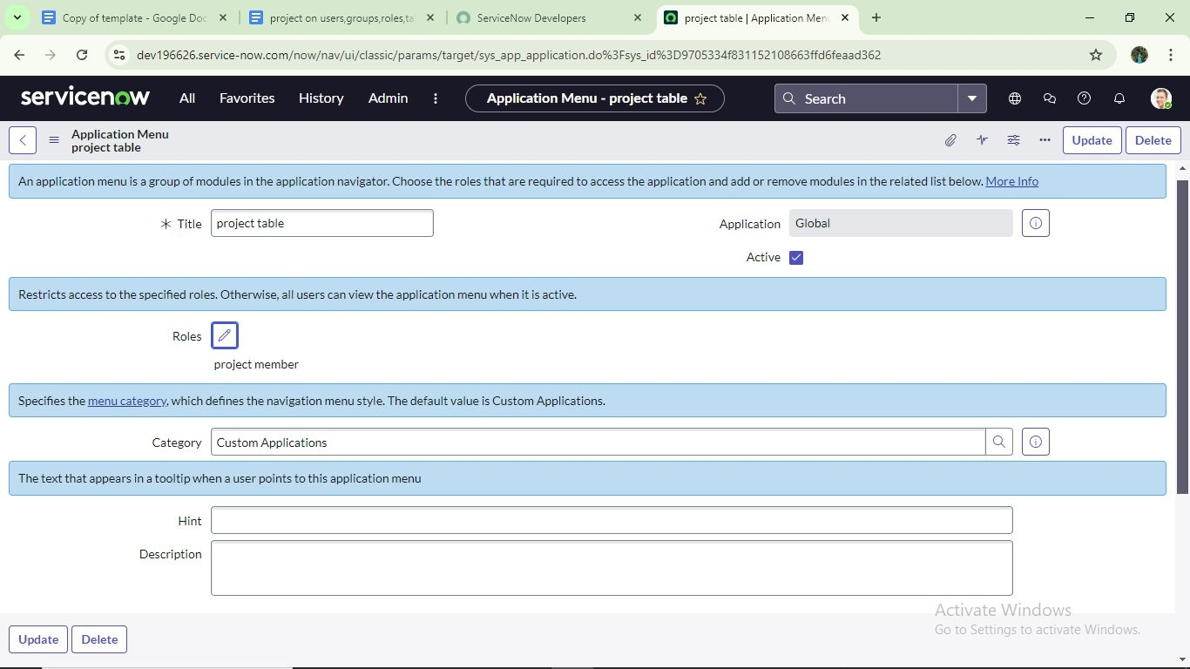

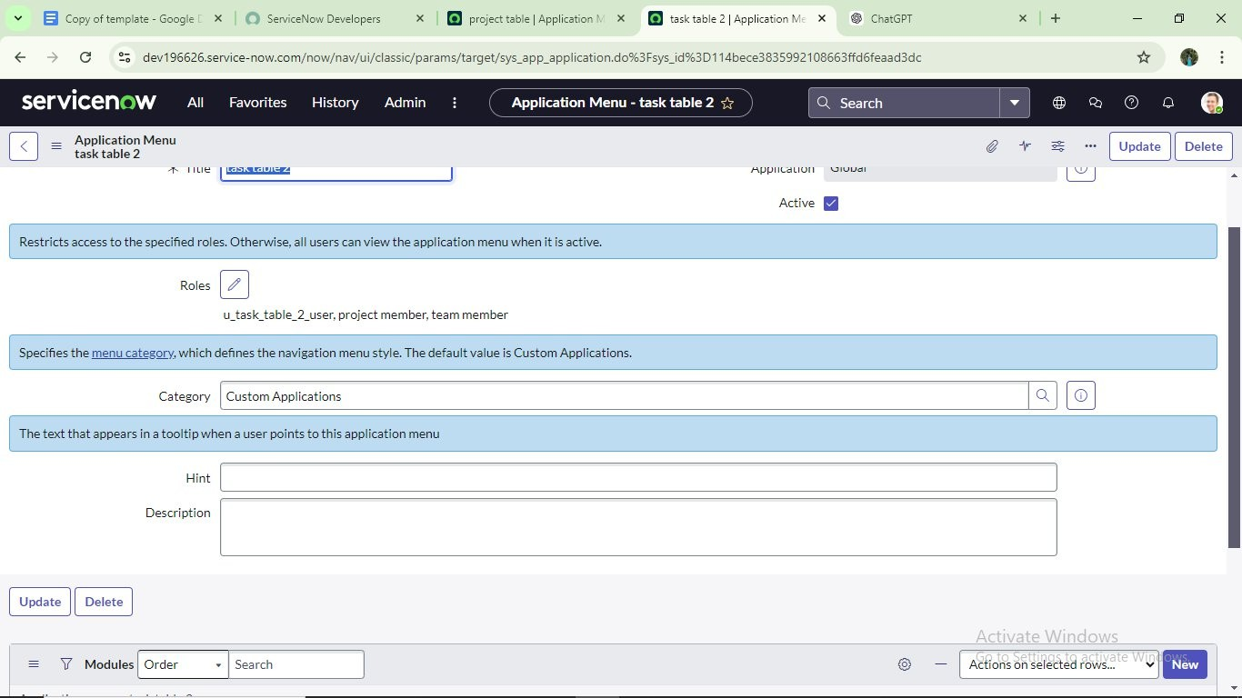

Milestone 8: Access control list

**Activity1:CreateACl**

1. Open servicenow.
2. Click on All >> search for ACL
3. Select Access Control(ACL) under system security
4. Click on elevate role
5. Click on new

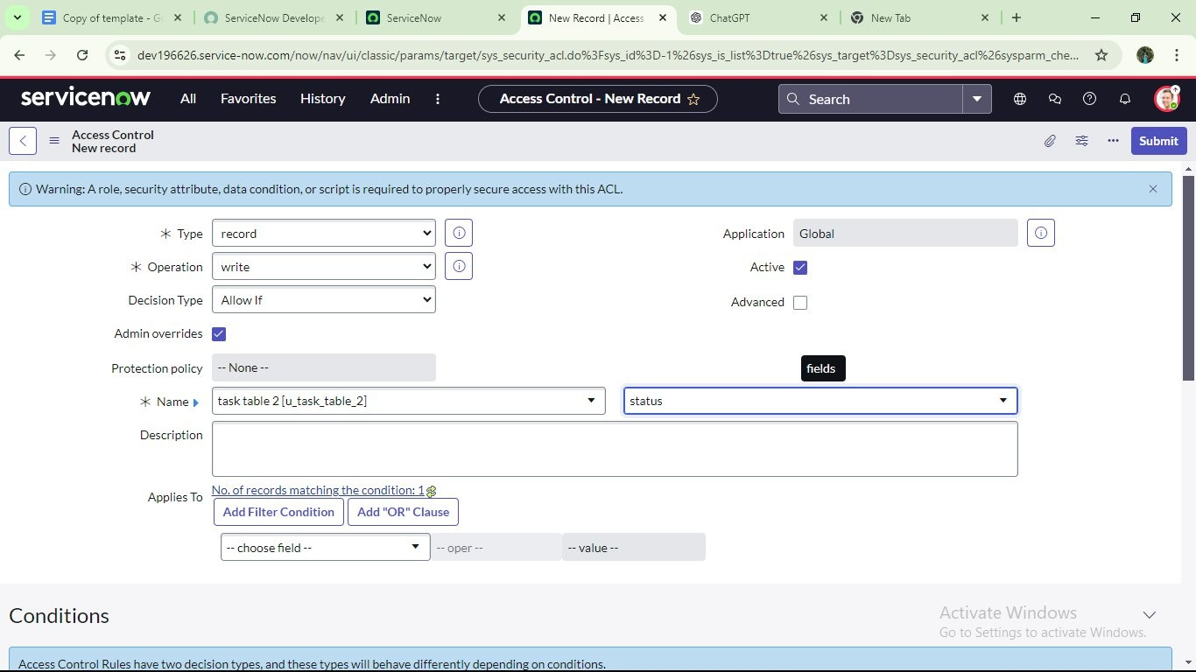

1. Fill the following details to create a new ACL
2. Scroll down under requires role
3. Double click on insert a new row
4. Give task table and team member role

10. Click on submit

11. Similarly create 4 acl for the following fields

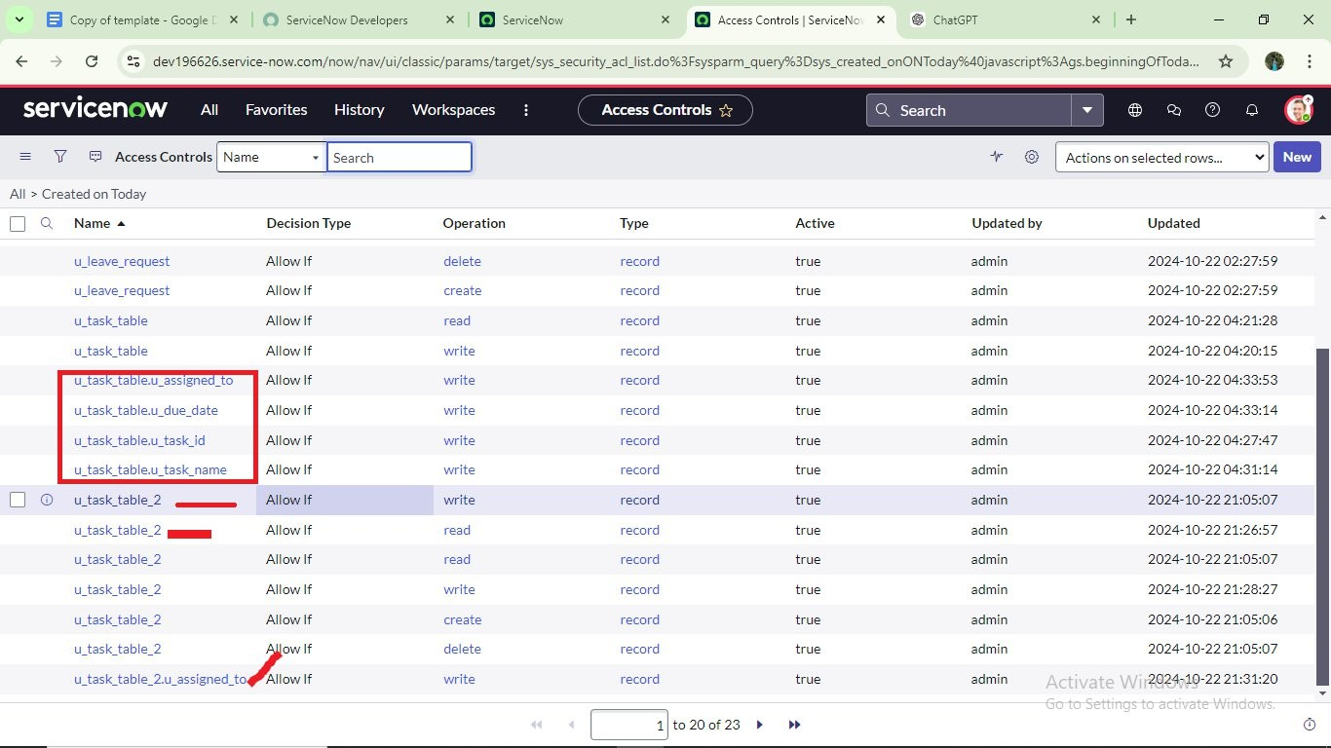

10.Click on profile on top right side

11.Click on impersonate user

12.Select bob user

13.Go to all and select task table 2 in the application menu bar

1. Comment and status fields are have the edit access

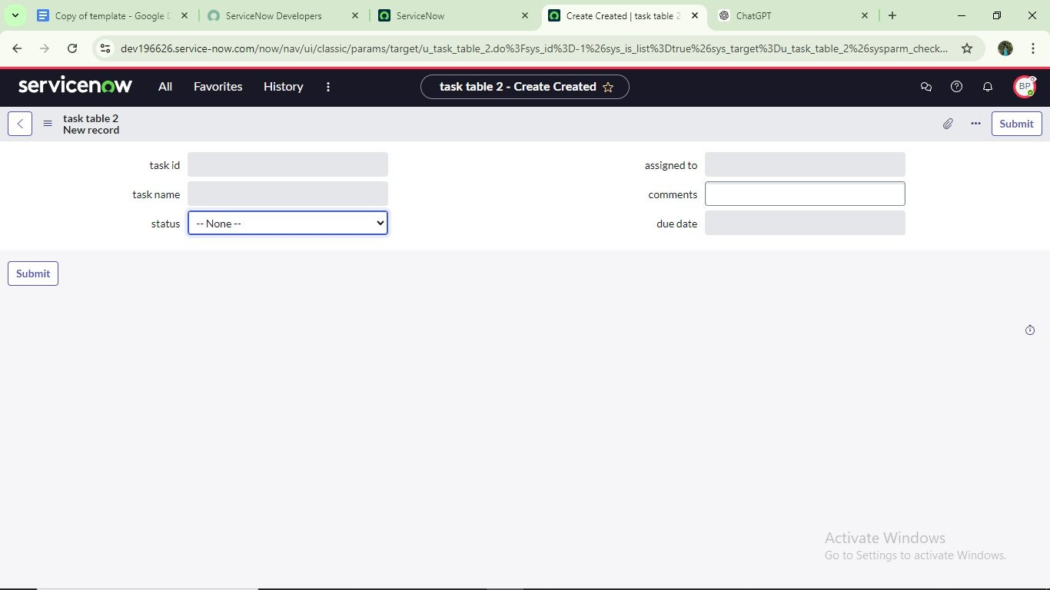

**Milestone9:Flow**

Activity1:CreateaFlowtoAssignoperationstickettogroup

1. Open servicenow.
2. Click on All>>search for Flow Designer
3. Click on Flow Designer under Process Automation.
4. After opening Flow Designer Click on new and select Flow.
5. Under Flow properties Give Flow Name as “tasktable”.
6. Application should be Global.
7. Click build flow.

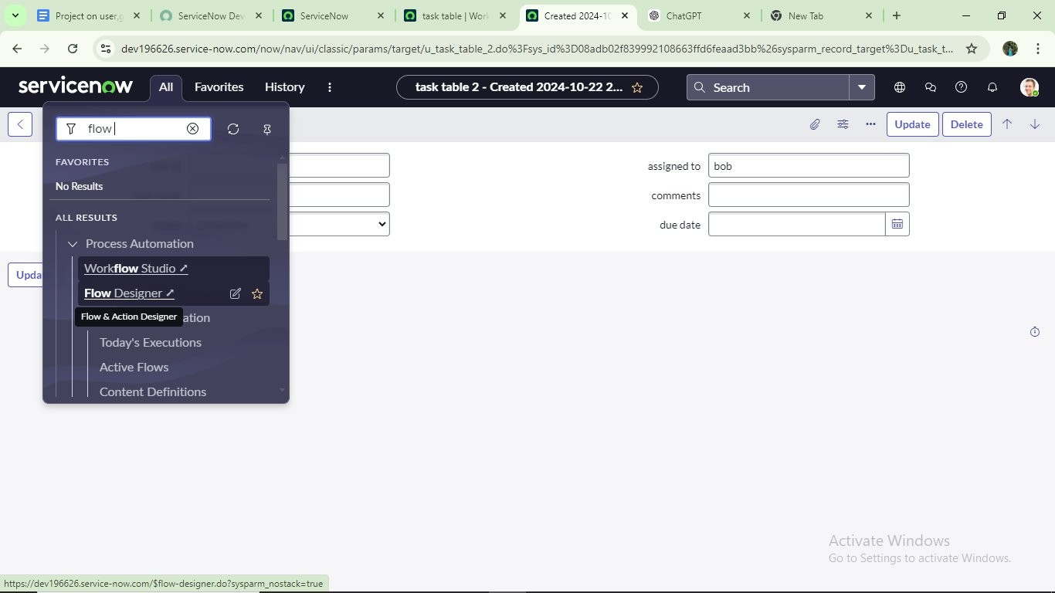

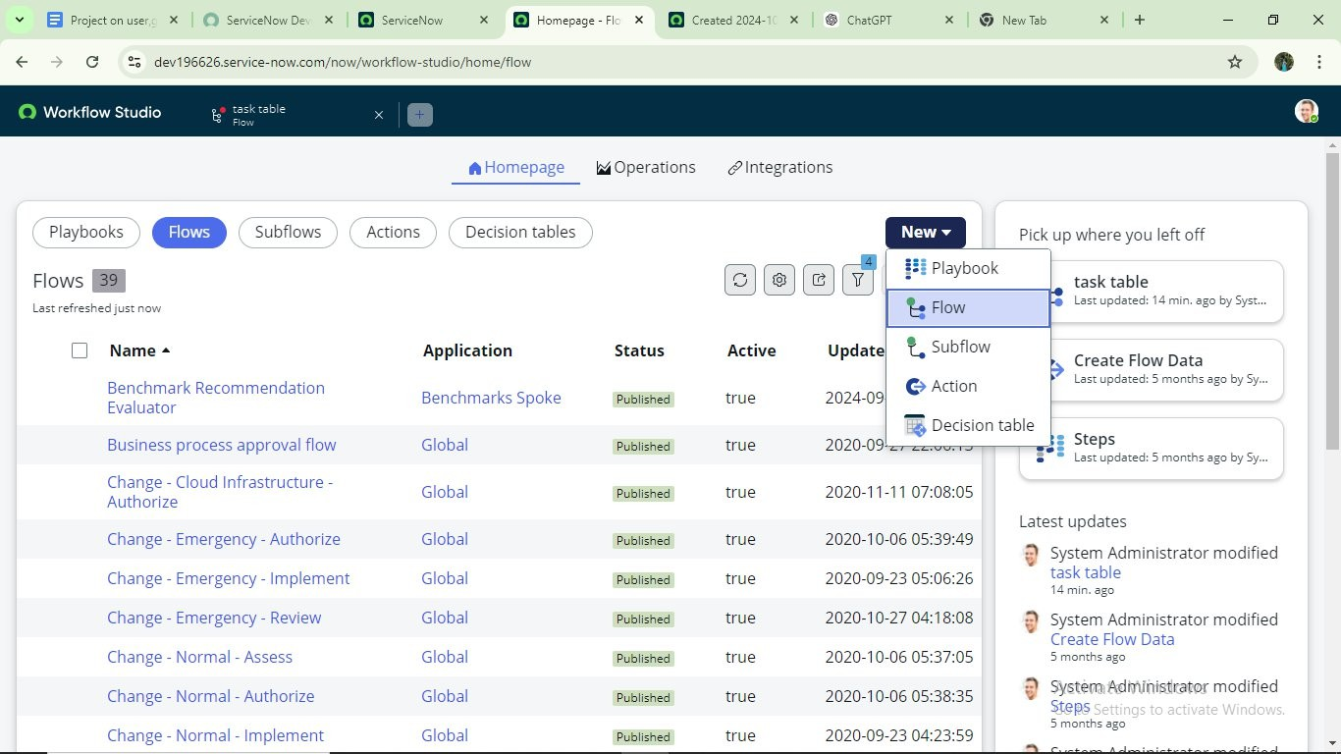

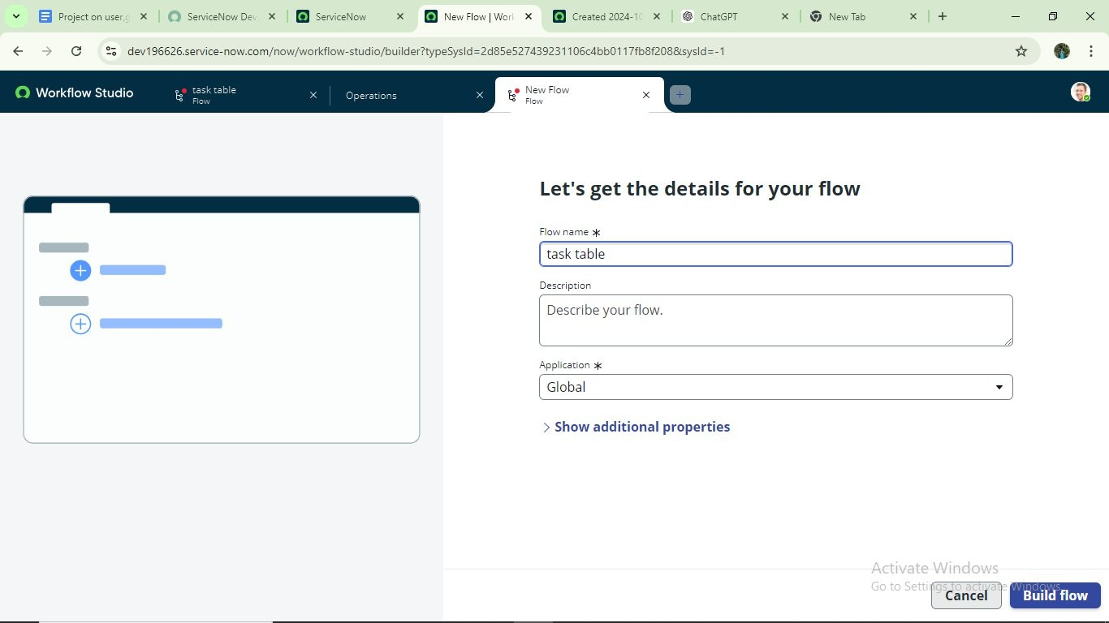

nextstep:

1. Click on Add a trigger
2. Select the trigger in that Search for “createrecord” and select that.
3. Give the table name as “task table”.
4. Give the Condition as Field: status Operator : is Value: in progress

Field: comments Operator: is Value: feed back Field : assigned to Operator :is Value : bob

1. After that click on Done.

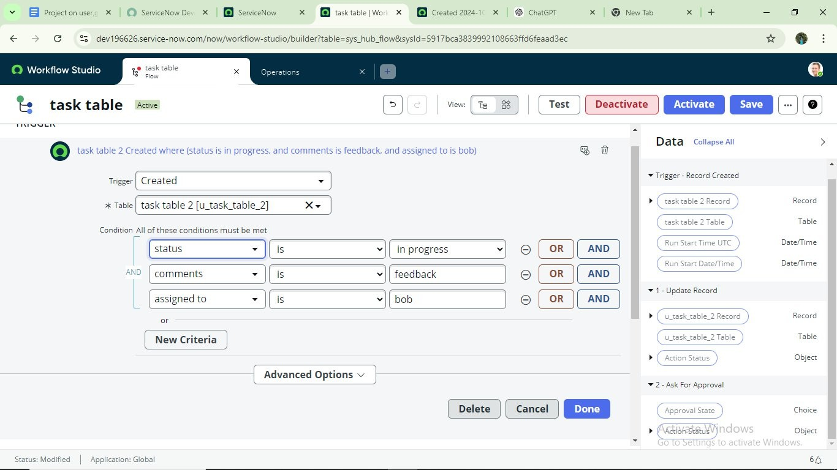

Nextstep:

1. Click on Add an action.
2. Select action in that, search for “update records”.
3. In Record field drag the fields from the data navigation from Right Side (Datapill)
4. Table will be auto assigned after that
5. Add fields as “status” and value as “completed”
6. Click on Done.

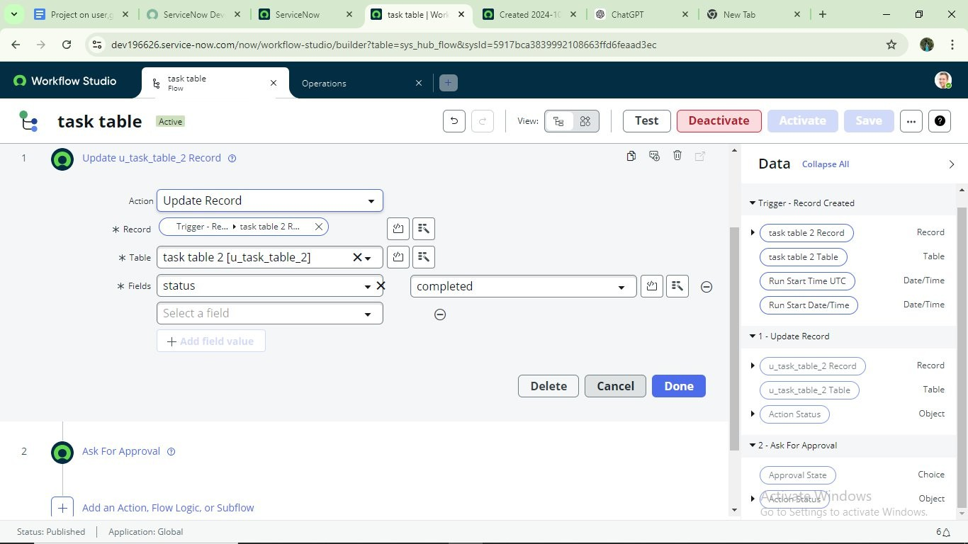

Nextstep:

1. NowunderActions.
2. Clickon Addan action.
3. Selectactioninthat,searchfor“askforapproval”.
4. InRecordfielddragthefieldsfromthedatanavigationfromRightside
5. Tablewillbeautoassignedafterthat
6. Givetheapprovefieldas“status”
7. Giveapproverasalicep
8. ClickonDone.

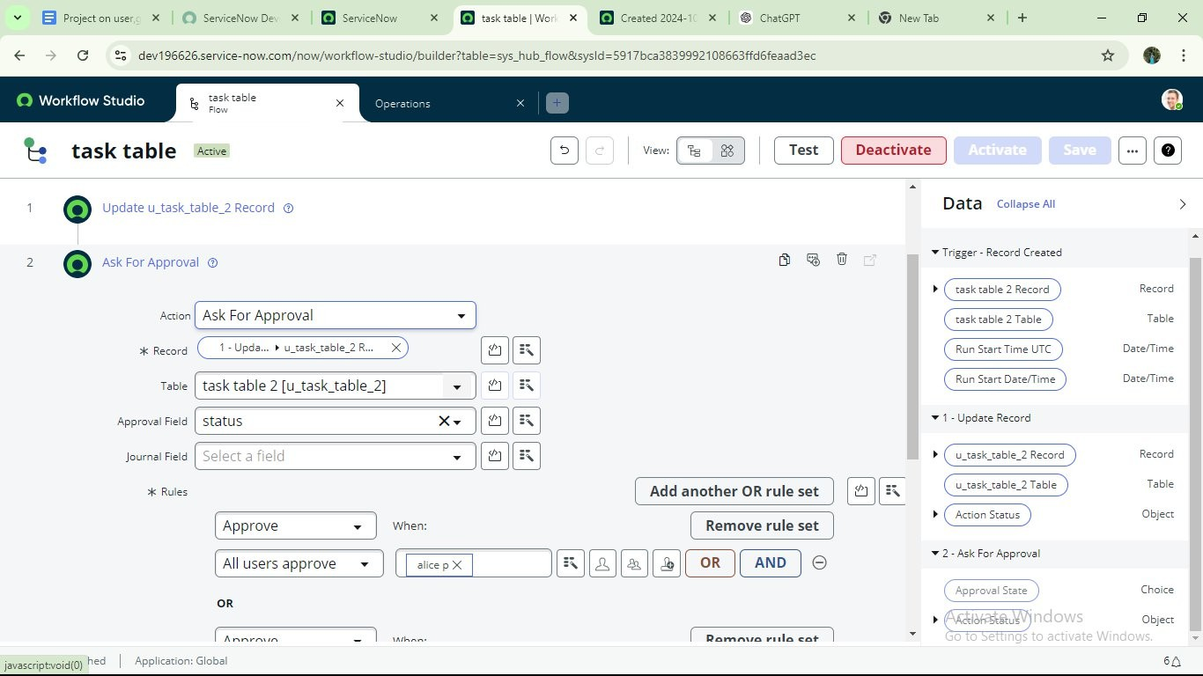

1. Go to application navigator search for task table.
2. Itstatusfieldisupdatedtocompleted

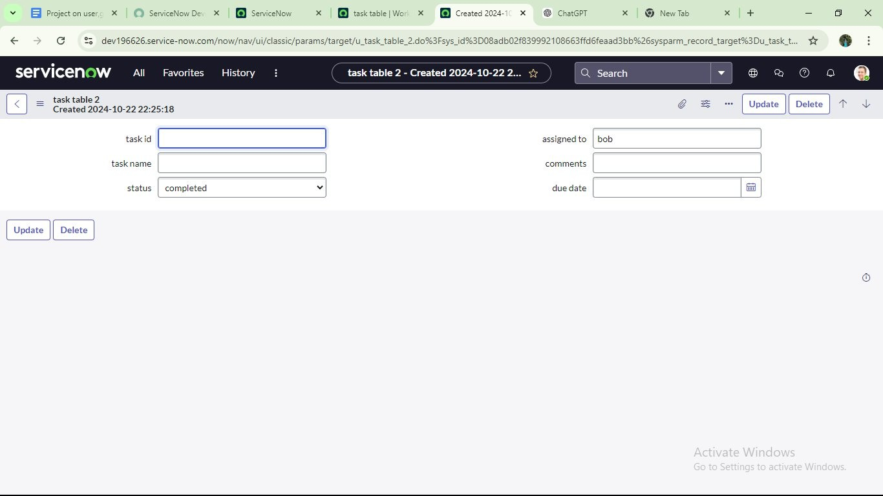

1. Gotoapplicationnavigatorandsearchformyapproval
2. Clickonmyapprovalundertheservicedesk.
3. Alicepgotapprovalrequestthenrightclickonrequestedthenselectapproved

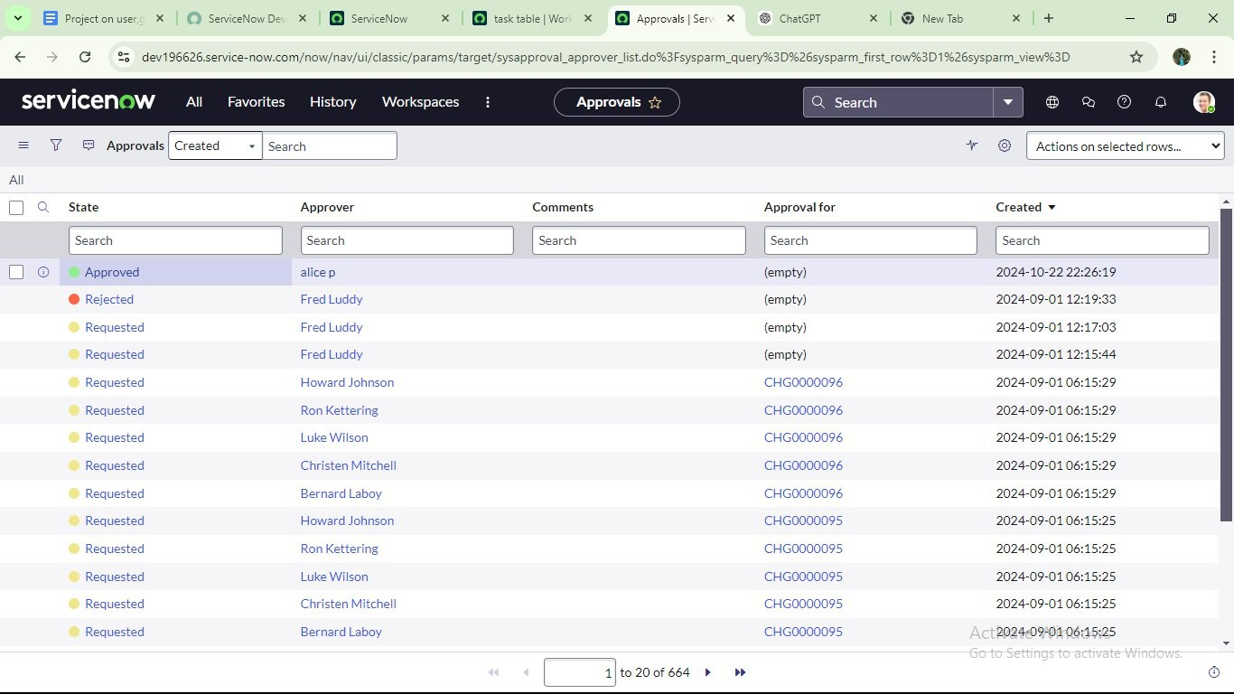

Conclusion:

This scenario highlights a structured approach to project management, showcasing the roles of Alice and Bob with in a defined workflow. With Alice's oversight and Bob's execution, the team effectively collaborates to ensure project success. The use of tables organizes key information, facilitating easy tracking of projects, tasks, andprogressupdates.Overall,thissystempromotes accountability, enhances communication, and leads to the successful completion of project